Project Title: A Hybrid Visitor Prediction Framework using Interpretable Temporal features, Integrating IQR and Anomaly Detection in Lakes in Nebraska.

Problem Statement:
Despite significant advances in machine learning for visitor forecasting, several important research gaps remain. First, anomaly handling is rarely treated as an explicit preprocessing step. Most visitor forecasting studies either ignore anomaly detection or rely on general data-cleaning procedures, even though anomalous observations can overestimate or underestimate visitation and negatively affect model performance. Second, model comparisons are often limited to a single family of algorithms, making it difficult to determine whether performance improvements result from better data preprocessing or the choice of learning algorithm. Moreover, individual models may suffer from algorithm-specific bias and may not consistently capture the complex spatial and temporal patterns of visitor behavior. Third, although spatio-temporal information is essential for visitor prediction, many existing studies underutilize interpretable temporal features and continue to rely on flat tabular representations that have limited generalizability across different locations and seasons. Finally, when multiple models produce similar prediction accuracy, identifying the most reliable model for practical deployment becomes challenging. These limitations highlight the need for a comprehensive framework that explicitly addresses data quality, systematically compares multiple machine learning models under identical experimental conditions, and evaluates whether hybrid ensemble learning can provide more accurate, robust, and stable visitor predictions.
Research Question
• RQ1: Does anomaly detection/IQR improve visitor prediction in terms of preserving data?
• RQ2: Can a hybrid model perform better than individual machine learning models?
• RQ3: Is one metric is enough for evaluation?
• RQ3: Do interpretable temporal features/lag improve visitor prediction accuracy?
• RQ4: Which model provides the most accurate and reliable predictions when different models show similar performance?
Objective:
The need for an accurate prediction of visitor numbers is becoming increasingly important for the effective management of protected landscapes, museums, parks and recreational areas, as it is decisions about staffing, infrastructure development, conservation and resource allocation that depend on reliable visitation estimates. While the access to large-scale mobile phone mobility data and the development of machine learning techniques have greatly enhanced the ability to predict the number of visitors, the quality of the mobility data is still a huge problem. Predictive models can be skewed by noisy observations, multiple signals, GPS drift, transmission inaccuracies, and abnormal visitation patterns in raw mobility data, which can cause erroneous management decisions. Although individual machine learning and ensemble models have been shown to work for visitor forecasting, few studies explore the benefits of explicit anomaly detection prior to the model building or compare the performance of anomaly detection against traditional outlier removal using the IQR. Also, it is not clear whether the performance improvements come from data preprocessing or from the model architecture. Moreover, the comparisons between various machine learning models are often restricted, which is problematic when multiple models yield comparable prediction accuracy. As a result, the need for a holistic framework that can address data quality while also comparing a number of machine learning models with the same experimental conditions and assess if hybrid ensemble learning can offer better accurate, robust, and stable visitor prediction for recreation management.
Spatial–Temporal Feature Engineering and Model Evaluation:

Features are divided in two categories
- Spatial
• poi_id_code
• home_*
• male_*
• female_*
• income_*
• white
• black
• native_american
• asian
• hawaiian_pacific
• other
• two_with_other
• two_ex_other_and_three_plus
- Temporal
In term of temporal data are divided into two
- Original Temporal ( Direct from dataset)

Hourly Visitation Features
- hh00
- hh01
- hh02
- hh03
- hh04
- hh05
- hh06
- hh07
- hh08
- hh09
- hh10
- hh11
- hh12
- hh13
- hh14
- hh15
- hh16
- hh17
- hh18
- hh19
- hh20
- hh21
- hh22
- hh23
ii) Interpretable (Created from dataset)
• Lag Feature : visitor count from the previous day
• day
• week
• month
• season
• is_weekend
• date_ordinal
• is_month_start
• is_month_end
• is_quarter_start
• is_quarter_end

Outlier removing Technique:
Outlier Removal (IQR): The Interquartile Range (IQR) method was applied to remove extreme values from the numerical features before model training.
Anomaly Removal: An ensemble of Isolation Forest (IF), Local Outlier Factor (LOF), and One-Class Support Vector Machine (OCSVM) was used to detect anomalous records. An observation was classified as an anomaly if at least two of the three models identified it as anomalous (majority voting). The top 2% highest-ranked anomalies were then removed before model training.
Record ID | Isolation Forest | LOF | OCSVM | Majority Vote | Final Decision
1 | 0 | 0 | 0 | 0/3 | Keep
2 | 1 | 1 | 0 | 2/3 | Remove
3 | 1 | 0 | 1 | 2/3 | Remove
4 | 0 | 1 | 0 | 1/3 | Keep
5 | 1 | 1 | 1 | 3/3 | Remove

Metrics: Five Metrics used for experiments

R² (Coefficient of Determination): This represents the proportion of variation in the data that is explained by the model. The nearer the value is to 1 the better the fit.
Mean Absolute Error (MAE): The mean of the absolute values of the difference between the actual and predicted values. The smaller MAE represents more accurate predictions.
MSE (Mean Squared Error): Calculates the average of the square of the errors of the predictions, which means that larger errors are weighted more heavily. The better the performance, the lower the MSE.
RMSE (Root Mean Squared Error): RMSE is the square root of MSE, expressed in the same units as the target variable, and is easier to interpret. The smaller the RMSE value, the better.
MAPE (Mean Absolute Percentage Error): Average of the absolute errors divided by the actual values expressed as a percentage. The lower the MAPE, the more accurate the prediction will be and the more easily it can be compared with other scales.

Result Analysis :
- In term of data reduction, Anomaly detection technique reduced only 5% of data where IQR removing 35.11% data.
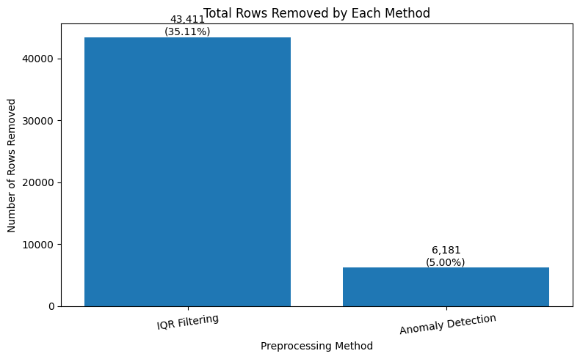

- After applying IQR and Anomaly detection technique improved performance.
In term of MLP(256,128,64) after applying IQR, MAE reduced from 1.705 to 0.640 with no lag feature. Moreover, after applying lag feature, it is reduced from 0.640 to 0.610. After applying IQR and experimented with lag many other methos like MLP (128,64) and ETR also showed improvement in terms of MAE, MSE, RMSE, R2 and MAPE.

Table 1: After applying IQR

Stage | Model | MAE (No Lag) | MAE (With Lag) | MSE (No Lag) | MSE (With Lag) | RMSE (No Lag) | RMSE (With Lag) | MAPE (No Lag) | MAPE (With Lag) | R² (No Lag) | R² (With Lag)
Before IQR Filtering | MLP (256,128,64) | 1.705 | 1.323 | 11.738 | 5.715 | 3.426 | 2.391 | 5.001 | 4.818 | 1.000 | 1.000
 | MLP (128,64) | 1.404 | 1.426 | 6.458 | 6.833 | 2.541 | 2.614 | 4.545 | 4.805 | 1.000 | 1.000
 | ETR | 4.468 | 4.746 | 1638.830 | 2162.719 | 40.482 | 46.505 | 1.732 | 1.828 | 0.994 | 0.992
After IQR Filtering | MLP (256,128,64) | 0.640 | 0.613 | 3.363 | 1.020 | 1.834 | 1.010 | 3.004 | 2.826 | 0.991 | 0.997
 | MLP (128,64) | 0.733 | 0.677 | 4.018 | 1.259 | 2.004 | 1.122 | 3.548 | 3.232 | 0.989 | 0.997
 | ETR | 0.559 | 0.550 | 7.428 | 3.011 | 2.725 | 1.735 | 1.823 | 1.859 | 0.980 | 0.992

After applying Anomaly Detection technique and experimented with lag MLP (156,128,64) method showing major improvement by reducing MAE from 1.600 to 1.403. It also showed significant improvement for other metrics like MSE, RMSE, and MAPE. R2 remained same for all technique. Moreover, other methods like Bayes and Ridge also revealed effective after using Anomaly and Lag feature.
#

Table 2: After applying Anomaly Detection

Stage | Model | MAE (No Lag) | MAE (With Lag) | MSE (No Lag) | MSE (With Lag) | RMSE (No Lag) | RMSE (With Lag) | MAPE (No Lag) | MAPE (With Lag) | R² (No Lag) | R² (With Lag)
Before Anomaly Removal | Bayes | 0.890 | 0.891 | 2.949 | 4.494 | 1.717 | 2.120 | 3.574 | 3.617 | 1.000 | 1.000
 | Ridge | 0.957 | 1.211 | 3.161 | 5.589 | 1.778 | 2.364 | 3.859 | 4.681 | 1.000 | 1.000
 | MLP (256,128,64) | 1.600 | 1.437 | 8.076 | 7.956 | 2.842 | 2.821 | 4.704 | 4.798 | 1.000 | 1.000
After Anomaly Removal | Bayes | 0.889 | 0.880 | 3.946 | 2.396 | 1.987 | 1.548 | 3.714 | 3.668 | 1.000 | 1.000
 | Ridge | 0.913 | 0.886 | 4.002 | 2.411 | 2.000 | 1.553 | 3.815 | 3.682 | 1.000 | 1.000
 | MLP (256,128,64) | 1.043 | 1.003 | 4.243 | 2.292 | 2.060 | 1.514 | 3.611 | 3.605 | 1.000 | 1.000

After Applying IQR and Anomaly detection to Hybrid models.

Compare result with base model and it shows that MSE and MAPE are showing higher than base models, but errors are less as hybrid models reduced MAE and MAPE value.

Table 3: Compare base model and hybrid model after applying anomaly detection technique

Category | Model | MAE | MSE | R² | RMSE | MAPE (%)
Base | MLP (256,128,64) | 1.003 | 2.292 | 1.0000 | 1.514 | 3.605
 | Ridge | 0.886 | 2.411 | 1.0000 | 1.553 | 3.682
 | Bayesian Ridge | 0.880 | 2.396 | 1.0000 | 1.548 | 3.668
Hybrid | STACK_GBR | 0.951 | 3.099 | 0.999946 | 1.760 | 3.406
 | VOTE | 0.862 | 3.687 | 0.999936 | 1.920 | 3.325
 | STACK_Ridge | 0.865 | 3.721 | 0.999935 | 1.929 | 3.310

- Actual vs Predicted output in terms of base model after applying base model Where Anomaly Detection technique showing more closely aligned with the observed values

IQR | Anomaly Detection
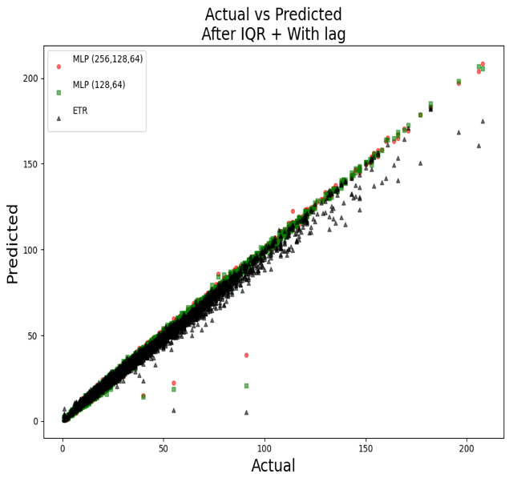 | 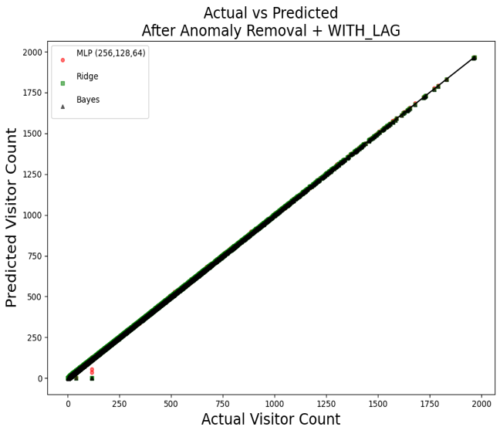

- Actual vs Predicted output in terms of base model after applying Hybrid model Where both Anomaly Detection and IQR technique showing more closely aligned with the observed values, but Anomaly detection is showing closer.

IQR | Anomaly Detection
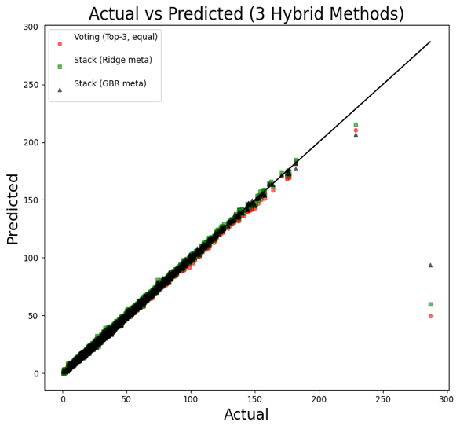 | 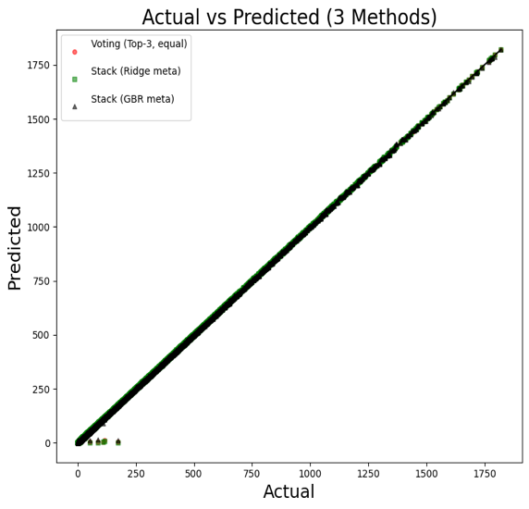

- In term of Anomaly detection, both base model and Anomaly detection technique are very closer. After considering MAE, Hybrid model is effective then base model as MAE is very less and around 9.81% improvement.
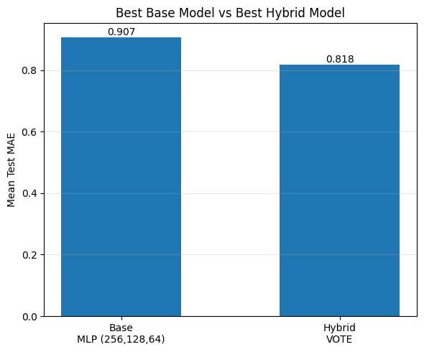
- Before applied K-fold validation after considering five metrics VOTE hybrid method indicated best in term of higher R2 and lower MAE,MSE, RMSE.
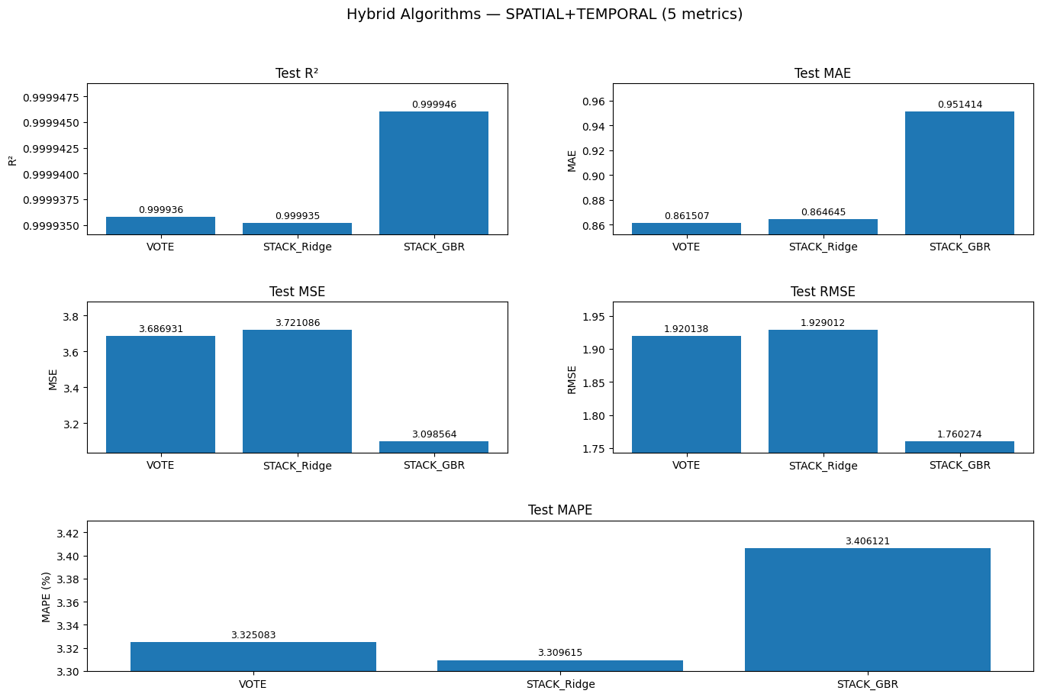
- Experiment with K-fold validation with anomaly detection technique 3 different splits where VOTE hybrid model showing effective performance.
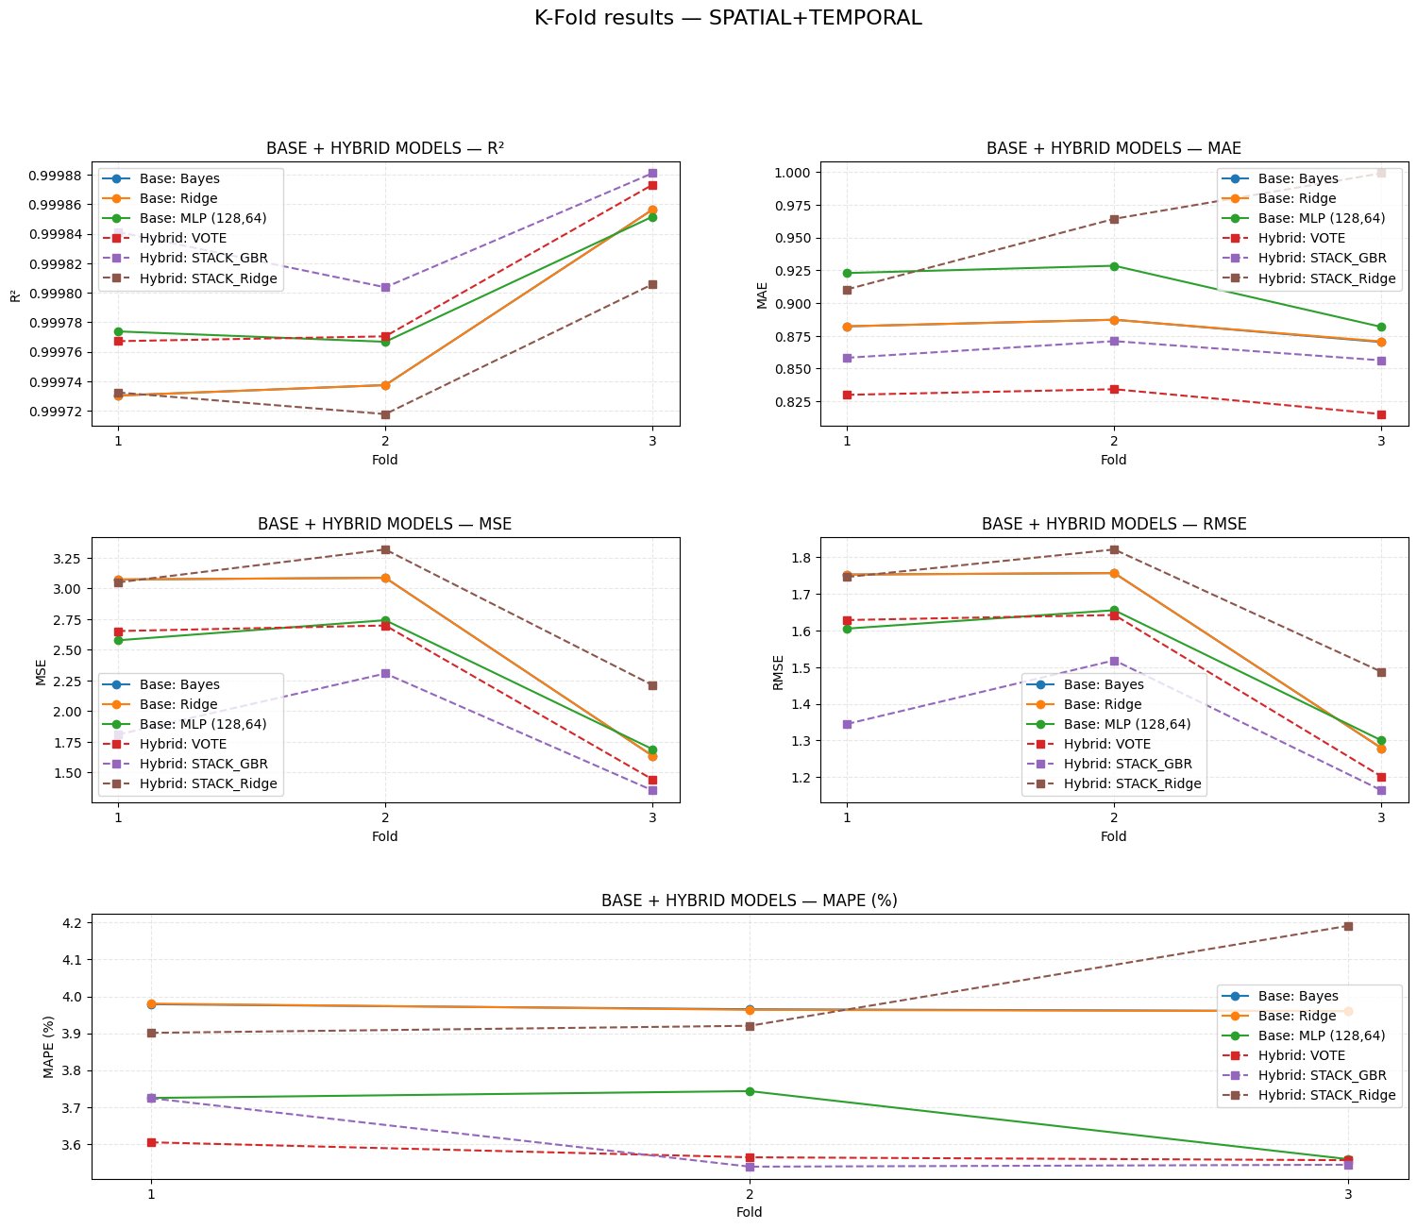
VOTE hybrid model indicated more efficient in term of all metrics
Table 3: Summarize the hybrid model in terms of 5 metrics

Table 4: K-Fold validation in-terms of IQR

Hybrid Model | Mean MAE ↓ | Mean MSE ↓ | Mean RMSE ↓ | Mean MAPE (%) ↓ | Mean R² ↑
STACK_Ridge | 0.906990 | 3.377647 | 1.835120 | 3.540943 | 0.999987
VOTE | 2.205798 | 300.798465 | 16.927260 | 3.392077 | 0.998871
STACK_GBR | 4.531633 | 750.901946 | 23.888775 | 7.099465 | 0.997227

Table 5: K-Fold validation in-terms of Anomaly Identification

Category | Model | MAE | MSE | R² | RMSE | MAPE (%)
Base | MLP (256,128,64) | 0.907074 | 2.290680 | 0.999803 | 1.513177 | 3.773141
 | Bayes | 0.880754 | 2.618631 | 0.999774 | 1.612985 | 3.973741
 | Ridge | 0.890911 | 2.619815 | 0.999774 | 1.619165 | 3.973542
Hybrid | VOTE | 0.818019 | 2.219127 | 0.999809 | 1.486550 | 3.517616
 | STACK_GBR | 0.865331 | 2.370002 | 0.999796 | 1.501891 | 3.574142
 | STACK_Ridge | 1.033668 | 4.946523 | 0.999572 | 2.102236 | 4.295037
Improvement | Best Hybrid (VOTE) vs. Best Base (MLP (256,128,64)) | 9.82% ↓ | 3.12% ↓ | 0.0006% ↑ | 1.76% ↓ | 6.77% ↓

From Table 4 and Table 5 it is proved that, after applying Anomaly identification technique, the hybrid model reduced MAE by 9.82%, MSE by 3.12%, RMSE by 1.76%, and MAPE by 6.77% compared to base model.

The best anomaly-based hybrid model (VOTE) reduced the MAE from 0.9070 to 0.8180 (9.81% improvement), the MSE from 3.3776 to 2.2191 (34.30% improvement), the RMSE from 1.8351 to 1.4866 (18.99% improvement), and the MAPE from 3.5409% to 3.5176% (0.66% improvement) compared with the best IQR-based hybrid model (STACK_Ridge).

- Negative bias indicates that the model is unpredicting and bias closer to zero indicates model’s effectiveness. Low variance means the model's prediction errors are consistent and stable across different samples. After applying Anomaly detection method, hybrid model showed less bias and less variance.

IQR | Anomaly Detection
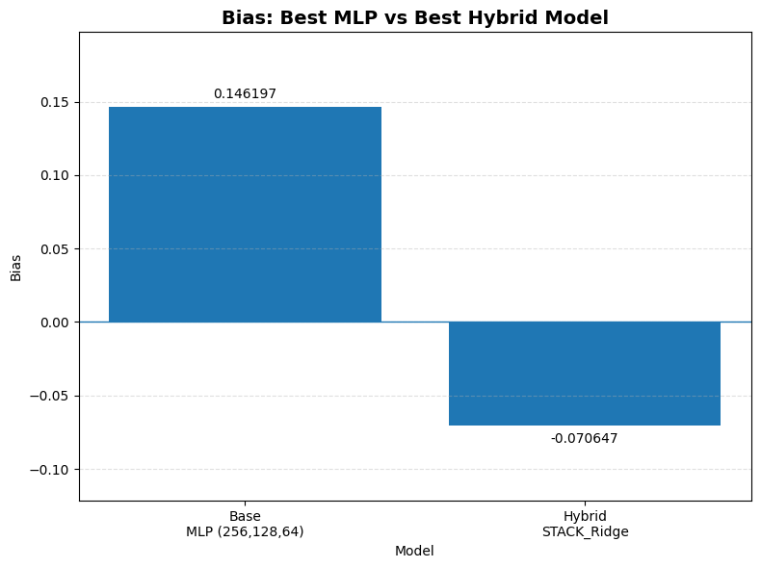 | 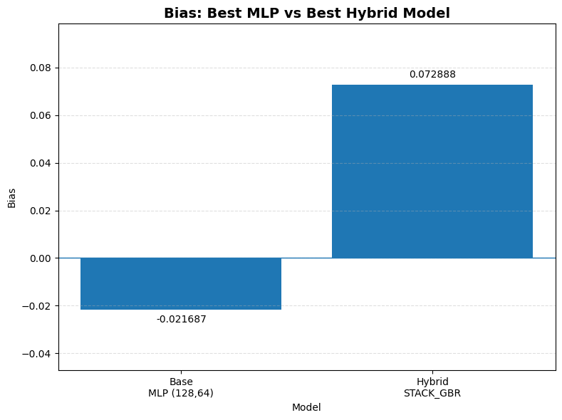
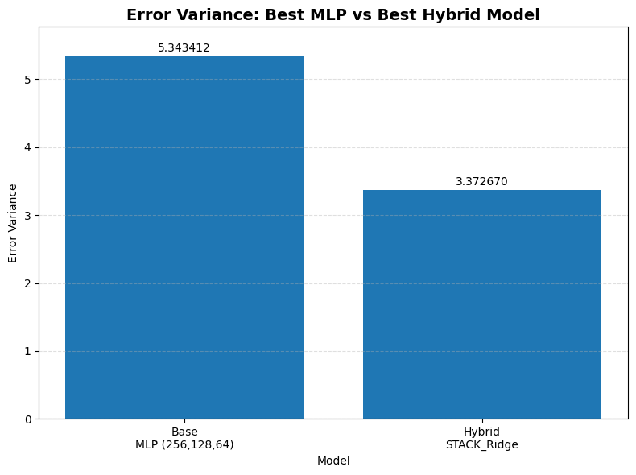 | 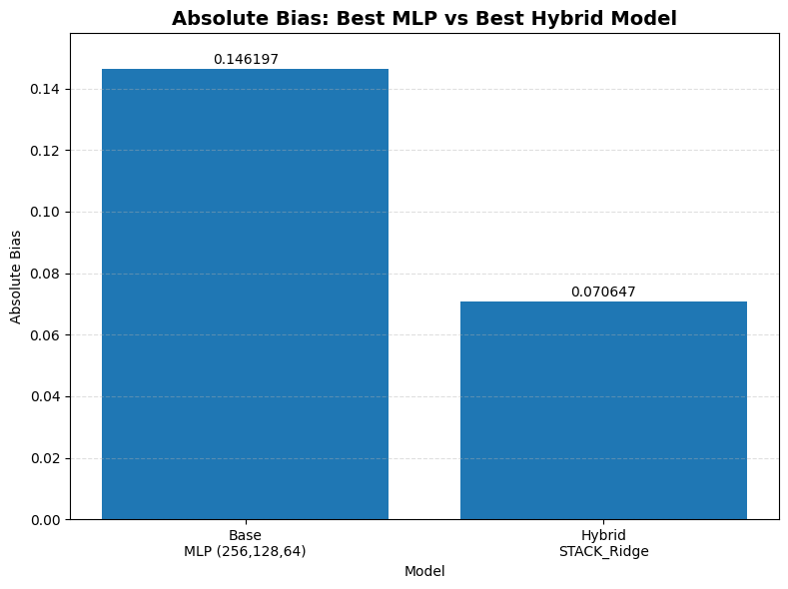

- Comparing IQR and Anomaly detection technique in term of K-fold validation it is showing around 9.81% improvement reducing MAE from 0.907 to 0.818

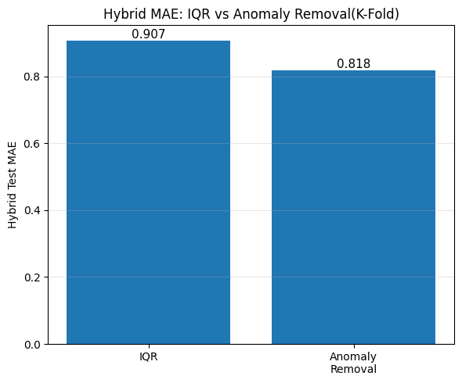

- Prediction sample:

Formula 1: Historical Robust Standard Deviation [1]
$$\text{Historical Robust SD}=1.4826×\text{MAD}$$
Where, median absolute deviation (MAD)
$$\text{MAD}=\text{Median}\left(∣x_{i}-\text{Median}∣\right)$$

Formula 2: Historical Standard Error
$$\text{Historical SE}=\frac{\text{Historical Robust SD}}{\sqrt{n}}$$
where:
- $n$= number of historical observations.

Formula 3: Predicted Visits
$$\text{Predicted Visits}=\text{Hybrid Model Prediction}±\text{Historical SE}$$

Example
Historical visits for the same lake and date:
Year | Visits
2022 | 115
2023 | 118
2024 | 122

Step 1: Median
$$\text{Median}=118$$

Step 2: MAD
$$∣115-118∣=3 \\ ∣118-118∣=0 \\ ∣122-118∣=4 \\ \text{MAD}=\text{Median}\left(3 , 0 , 4\right)=3$$

Step 3: Historical Robust SD
$$\text{Historical Robust SD}=1.4826×3=4.45$$

Step 4: Historical Standard Error
Number of historical observations:
$$n=3 \\ \text{Historical SE}=\frac{4.45}{\sqrt{3}}=\frac{4.45}{1.732}=2.57$$
The code rounds the uncertainty to the nearest integer:
$$\text{Prediction Uncertainty}=\text{round}\left(2.57\right)=3$$

Step 5: Final Prediction
Suppose the hybrid model predicts 120 visits.
$$\text{Predicted Visits}=120±3$$
Prediction range:
$$120-3=117 \\ 120+3=123$$

Prediction Sample:
==============================
Prediction
==============================
Lake ID : 6080.0
Lake Name : Mormon Island West (MM 312N)
Hybrid Model : STACK_GBR
Feature Combo : SPATIAL+TEMPORAL
Historical Robust SD : 18.53
Historical SE : 7.57
Predicted Visits : 38 ± 8
Prediction Range : (30 - 46)

==============================
Historical Same-Date Data
==============================
Year Date Actual_Visits
2022 2022-01-03 12.0
2022 2022-01-03 17.0
2022 2022-01-03 33.0
2022 2022-01-03 21.0
2022 2022-01-03 44.0
2024 2024-01-03 108.0

==============================
Prediction
==============================

Lake ID : 6080.0
Lake Name : Mormon Island West (MM 312N)
Date : 01-04
Matched Date : 01-04
Rows Used : 2
Hybrid Model : STACK_GBR
Feature Combo : SPATIAL+TEMPORAL
Historical Robust SD : 57.82
Historical SE : 40.89
Predicted Visits : 66 ± 41
Prediction Range : (25 - 107)

==============================
Historical Same-Date Data
==============================
Year Date Actual_Visits
2022 2022-01-04 30.0
2024 2024-01-04 108.0

Summary:

This study presents a hybrid visitor prediction framework for Nebraska lakes that integrates spatial, temporal, interpretable temporal, and lag features with anomaly detection and IQR filtering to improve visitation forecasting. Multiple base models are evaluated, and the top-performing models are combined using voting and stacking ensembles to enhance prediction accuracy and robustness. Experimental results show that lag features and anomaly removal reduce prediction error, while hybrid models consistently outperform individual models. In particular, after applying Anomaly identification technique, the hybrid model reduced MAE by 9.82%, MSE by 3.12%, RMSE by 1.76%, and MAPE by 6.77% compared to base model. Moreover, the proposed anomaly detection method achieved greater improvement by 9.81% in MAE compared to the IQR filtering method. demonstrating its effectiveness for reliable visitor prediction and recreation management

Upcoming Step:

Future step will concentrate on implementing the proposed hybrid visitor model as a web-based application for real-time visitor forecasting. The system will offer an interactive user interface for lake selection, for selecting dates and for making predictions of the number of visitors including estimates of uncertainty, for use in data-driven decision making for recreation management.

Reference:

1. https://en.wikipedia.org/wiki/Median_absolute_deviation

